Name:__________________________________________________________ Date:__________________ Period:______
Scramble for Africa- Webquest
Use the Video, World History Atlas pages 88-89 and the PowerPoint Notes to answer the following questions:
- What is Colonization?

- Colonization was important to Europeans because….
1.
2.
3.
4.
5.
6.

- What is the Scramble for Africa and what were some of the effects?

- What happened at the Berlin Conference?

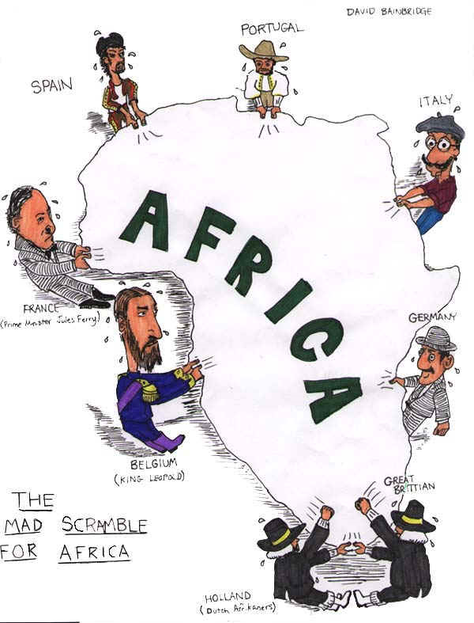
- Explain the meaning of the political cartoon:

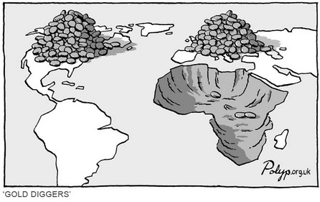
- Explain the meaning of the political cartoon:

